COMSATS University Islamabad
Attock Campus
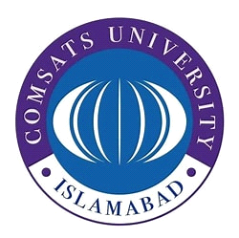

Department Of Computer Science

Name | Faareh Ishaq
Registration No. | Fa23-BSE-021
Submitted To | Mr. Muhammad Kamran
Course | Mobile Application Development
Assignment no. | 03

Code:
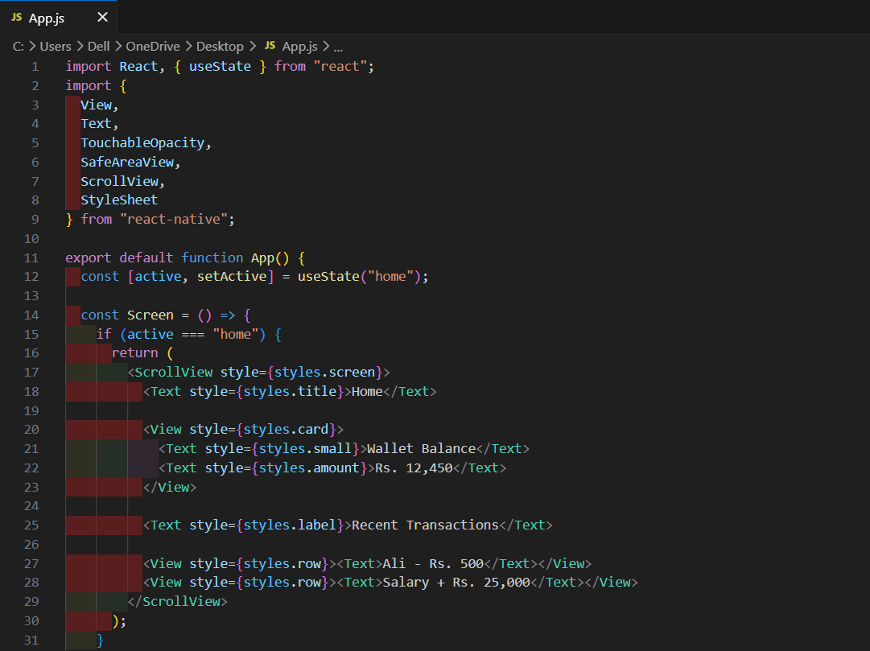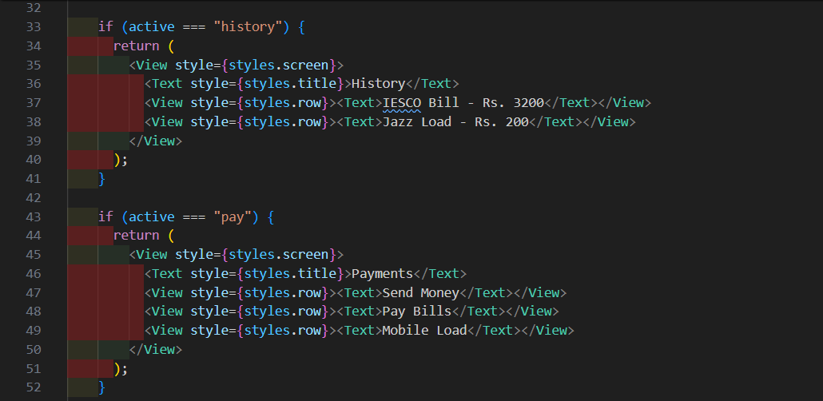

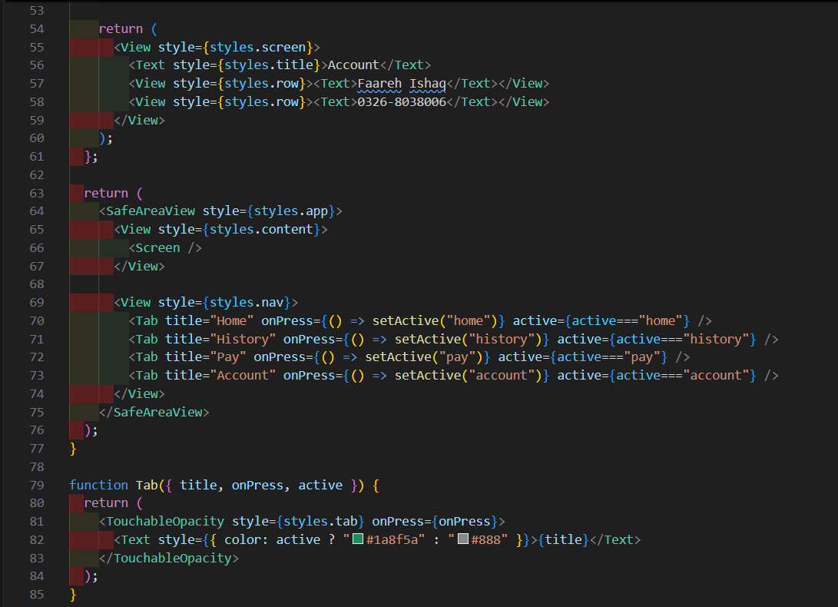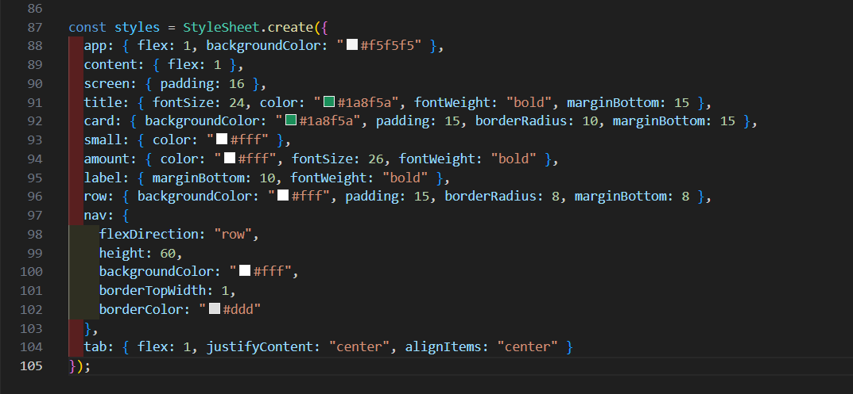

Output Screens:
Home:
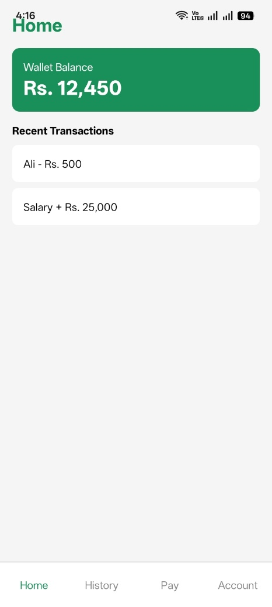

History Screen:
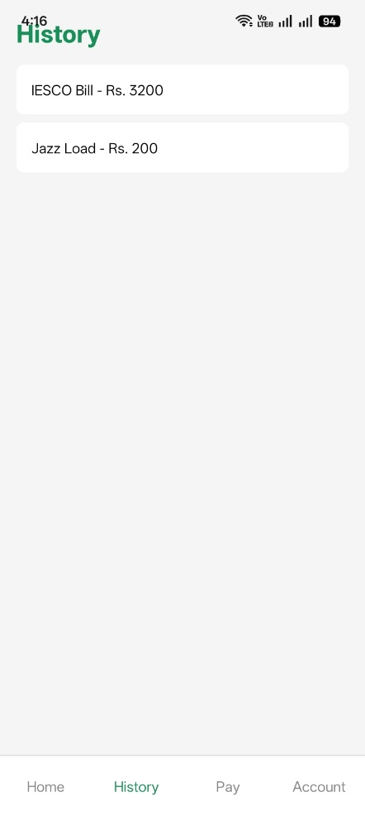

Payments Screen:
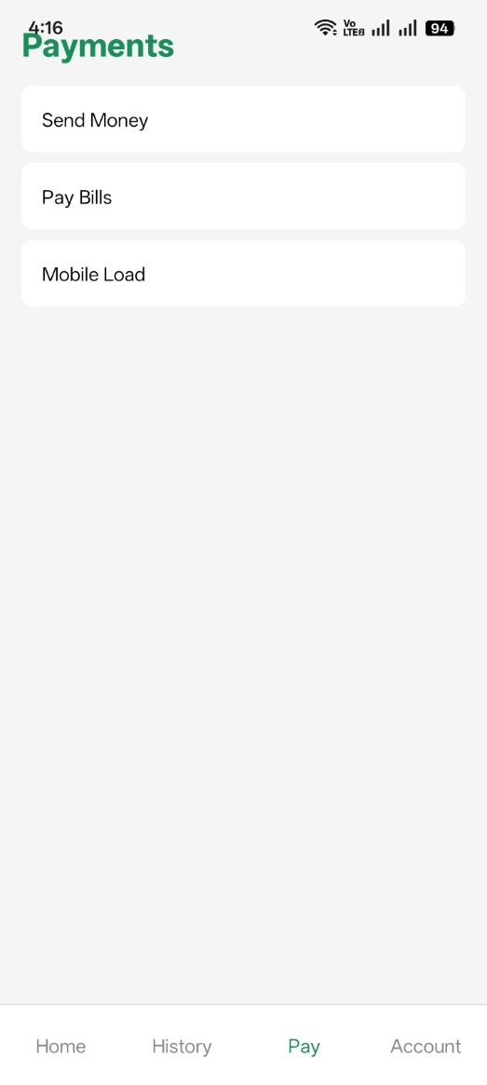

Account Screen:
